CHAPTER TWO
SYSTEM ANALYSIS
2.1 Existing system
There are many websites that connect customer with service. Among these betoch.net and makina.net are some of them. The site betoch.net is an online house buy, sell and rental service provider.Makina.net is also an online site that provides car rental and sale services. Even though these applications are developed for providing services we are aimed to do on, their scopes are very few. For instance the website betoch.net gives information about house only. The same is too for makina.net which provides information regarding car rental and sale. They are all web based and require a working and installation of web browsers on your system. Each service provider has it’s own websites by the current advanced system. This and other combine together and push us to develop an android based application which provides the more general service including guards and house servants.

2.2.1 Existing system description
Most of the systems we are going to develop are not in work in the current system i.e no system is developed for it so we can’t find this services in mobile frames or web too.So user are using the following methods to use the services we are going to build:
1.To get the service of House and Vehicle either for rent/sale
- Open a web browser on his device.i.e need to have a working installation of web browser.
- Browse the site i.e Betoch.net for house and Mekina.net for car service.
- The site don’t care about what is posted i.e no persistence check of the information posted is carried out by the system.
- To access the service,payment will take place through online means.
Apart from this all,the services are posted by the user them selves.The user can post every thing he went which may be for fake,and even if real he may include additional information that his service doesn’t have.Through the current system their is no way to check for this information.Thus this may result in the user being bored with system.

2.2 Existing system business rule
A business rule is an effectively operating principle or polices that we try to specify for both the existing system and the new system must satisfy. The business rule is a principle or a policy in which the proposed system operates accordingly. It deals with access control issues.It often pertains to access control issues, operating policies and principles of the organization. The organization has the following principles in the existing system which includes:
BR1:The existing system only provides a specific service while our system contain 4 services together.
BR2: The customer should have to register.
BR3: The user should fill the form properly.
BR4: Only the customers who have a valid login can get access to the service.
BR5: The customer should have to fill their bank account number to get access to the service.
BR6: The system should work 24 hours,when their is an internet access.
BR7: The system should secure the way the service is accessed.
BR8: The system should update the information when there is change in the information.
BR9: The system should automatically delete the service and it’s information from database when it’s accessed by any customer.
BR10: The system should reduce from the customers bank account/balance when he wants to access service.

Alternate solution
The problems we explained above makes the existing system hard to use for users because the services we are going to be built cannot be found in one place, users have to search different places to use the services
- The best alternative solution to solve the problems described above is to change the system by a new system that the user can get these four services in one place in their mobile phone without going and searching different places and also making the services available for free.
2.3 Proposed System
Digital broker is a server based mobile application.This application contains server side containing the database of the services, customer and broker; and a client side containing GUI (graphical user interface).And our system will also have detailed information about the services (house, vehicle, guards and house servants). This system enables customer to search and view details of their need posted by the broker and will generate and forward announcement and the need notifications for the owner. It wills also shortlist the currently available needs.
This provides customers with a very interactive experience with the application. Customers are given the facility to register themselves. Upon registering, the customer gets to have a profile of his own and also provide feedback. An additional feature that we have included in the customer’s application is that two or more customers can place order from remote locations. This application helps seekers to view and search for their need by accessing it through mobile without the need for moving physically from broker to broker,installation of web browser and remembering the domain name of the website.

2.3.1 Functional Requirements
The Functional Requirements Specification specifies the operations and activities that a system must be able to perform. Functional requirements should include functions performed by specific screens, outlines of work flows performed by the system, and other business requirements the system must meet.

- Administrator
- Registering brokers(Create account).
- Manage brokers(Update and delete brokers account).
- View report.
- Broker
- Update his profile.
- Upload service information.
- View service information.
- Update service information.
- Delete service information.
- Generate report.
- View notifications.
- Send notifications
- View user feedback.
- Customer
- Register and login.
- View services.
- View notification.
- Send feed back.
- Order existing service.
- Make call.
- Make payment.
2.3.2 Non-functional requirements
Non-functional requirement is a requirement that specifies criteria that can be used to judge the operation of a system, this requirement does not directly affect the performance of the proposed system but, they concerned with security, performance, usability, maintainability, reliability, efficiency, portability (across operating systems) testability, understand ability etc.The non-functional requirements of the system are presented below: -
- User Interface: - users require the interface to be attractive and user-friendly with easy navigational scheme.
- Security issue: - provides security tasks such as for registering, for modifying user’s information and viewing needs authentication and authority.
- Maintainability: - When the system fails, it can be maintained easily.
- Performance: - the performance of our system is measured in terms of load time and number of requests handled. So it is fast in accepting inputs and displays the result as well as requires small space.
- Error handling Mechanism: - handles invalid inputs and display user error in meaningful messages.
- Availability: - The system will be available for 24 hours to users with internet connection.
- System requirement:-Our system requires software and hardware requirements. These are:-
A) Hardware requirement
    - Flash 16 GB
    - Laptop
    - RAM size 4 GB or more
    - Processor speed 2.5 GHZ or more
B) Software requirement
    - Notepad ++
    - XAMP Server
    - Edraw Max
    - Mozilla Firefox, Baidu browser
    - Microsoft office word 2016
- Backup and Recovery: - The system should store a backup database daily the system may face some errors on the data base server.
- Others
- Internet connection.
- Dedicated lab room.

2.3.3 Use case diagram
A use case is a sequence of action that provides a measurable value to an actor.
- Use case components:
- Actor: is a person, or external system that plays a role in one or more interaction with the system. And represented with:

Fig 2.1 actor notation
- Use case: describes a sequence of actions that provides something of measurable value to an actor and is drawn as a horizontal ellipse.

Fig 2.2 use case notation

- System boundary: indicates the scope of the system project. Anything within the box represent functionalities in side in scope.

Fig 2.3 Notation for system boundary

Include Relationship: A part of use case which appears in the same identical form in other use cases may be transferred to its own use case and re-integrated universally via an Include relationship in order to avoid the redundant specification of these identical parts.
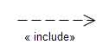
Fig 2.4 Notation of include relationship

Extend Relationship:The Extend relationship points to the use case to be extended, and starts from that use case which describes the extension's behavior.
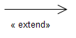
Fig 2.5 Notation of extend relationship

Actor description

Customer: -a Person who want to see information of service and can get access of the service.
Admin:-is the person who is in charge of managing and administering the system.He manage the system access right for others. Register brokers and manage their accounts .
Broker: -an actor that posts the service information and can made any transaction on them.He have role of a supervisor in the sense that he controls the sites, enter new service information, update information, delete information, search information’s and can read user feed backs.
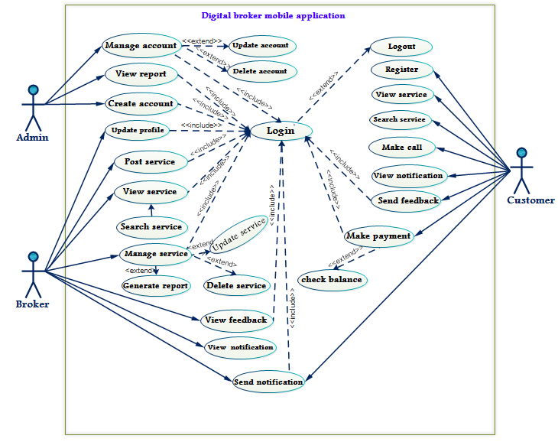
Fig 2.6 Use case diagram of the system.

2.3.4 Use case documentation

Table 1.1 Use case documentation of Login
Use case name  Use case number  Actor(s)  Description | Login  Uc#1  Broker,Customer,Admin  Helps to control the system from unauthorized persons to access the system
Typical course action | Actors action:  Step1.The actor click on login button.  Step3.The actor enters user name and password.  Step4.The user click login button | System response:  Step2. The login page displayed.  Step5.The system verifies the authority.  Step6. The system displays the actors page.  Step8. The use case ends.
Alternate course of action | Step7.If the actor enters invalid user name or password, the system displays error message and goes to step 3.
Pre-condition: | The actor must be registered first and the list must be found in the database.
Post-condition: | The actor can do anything in the main page with his/her privileges.

Table 1.2 Use case documentation of registration
Use case name  Use case number  Actor(s)  Description | Register  Uc#2  Customer  Helps to register the customer for accessing the services.
Typical course action | Actors action:  Step1.The customer wants to register himself to access services.  Step3:The user enters the necessary information in to the form in the registration page.  Step4:The user clicks on register button. | System response:  Step2:The system displays registration page.  Step5:The system validates whether the information submitted is correct or not.  Step7:The system registers and displays registration successful message and leads to home page.  Step8:The use case ends
Alternate course of action | Step6.If the entered information is not valid the system displays an error message and goes to step 3.
Pre-condition: | The customer must fulfill whatever required information like bank account number, phone number etc…
Post-condition: | The customer can easily access the service by login to the system.

Table 1.3 Use case descriptions for Create an Account.
Use case name  Use case number  Actor(s)  Description | Create Account  Uc#3  Admin  The admin creates an account for brokers so as they can manage the services.
Typical course of action: | Actor Action | System Response
Typical course of action: | Step1:This use case is initiated when the actors clicks on the create account option  Step3:The actor enter the required information. | Step2:The system displays the create account page.  Step4:The systems checks the information is correct or not.  Step6:Use case ends.
Alternative course of action: | Step5:If the actor does not fill the required information then the system display error message and return to step 3.
Pre-condition: | The Actor must have a privilege to create an account.
Post-condition: | The Actors should create account.

Table 1.4 Use case documentation of Manage Account
Use case name  Use case number  Actor(s)  Description | Manage Account  Uc#4  Administrator  Helps to create, delete, and deny user account for users of the system and sets privilege to them.
Typical course action | Actors action:  Step1.The administrator wants to update Account of a user  Step4.The administrator clicks on manage account button.  Step6.The administrator selects a user/broker, for whom to manage account.  Step7.The administrator then update/delete the users/brokers account by inserting necessary information. | System response:  Step2.The system includes login page.  Step3.The system displays an account page.  Step5.The system displays the users/brokers account page.  Step8.The system verifies validity of the brokers information and response with success message.  Step10.Use case ends.
Alternate course of action | Step9.If the entered incorrect information while updating, the system displays an error message and goes to step7.
Pre-condition: | The Administrator must have a privilege to login.
Post-condition: | The Administrator will update/delete user/brokers account.

Table 1.5 Use case documentation of delete
Use case name  Use case number  Actor(s)  Description | Delete service  Uc#5  Broker  The broker can delete any service at a time when he wants.
Typical course action | Actors action:  Step1.The broker wants to delete service information from the system.  Step2.The broker login to his page.  Step4.The broker clicks on service button.  Step6.The broker clicks on the service he want to delete.  Step8.The broker clicks on OK button. | System response:  Step3.The system displays the brokers page.  Step5.The system displays the available services.  Step7.The system displays a pop-up menu asking you want to delete? Query.  Step10.The use case ends.
Alternate course of action | Step9.If the broker clicks on cancel button the system will go back to step5 .
Pre-condition: | The broker must have a privilege to login.
Post-condition: | The broker successfully delete service from the system and the service will not be accessible forward.

Table 1.6 Use case documentation of send notification
Use case name  Use case number  Actor(s)  Description | Send notification  Uc#6  Broker,customer  The actors can send notification to whom they want to.
Typical course action | Actors action:  Step1.The actor wants to send notification.  Step2.The actor login to his page.  Step4.The actor clicks on send notification button.  Step6.The actor clicks on OK button. | System response:  Step3.The system displays the actors page.  Step5.The system displays the notification page.  Step7.The system displays successfully sent message.  Step8.The use case ends.
Alternate course of action | Step9.If the actor clicks on cancel button the system will go back to step3 .
Pre-condition: | The actor must have a privilege to login.
Post-condition: | The actor successfully send notification to whom he want to send.

Table 1.7 Use case documentation of view service
Use case name  Use case number  Actor(s)  Description | View service  Uc#7  Broker,customer  The actors can view the service he want to see and get access to.
Typical course action | Actors action:  Step1.The actor wants to view the service.  Step2.The actor visit the site.  Step4.The actor clicks on the service he want to view.  Step6.The actor views the services. | System response:  Step3.The system displays the homepage.  Step5.The system displays the service page.  Step7.The use case ends.
Alternate course of action | Step8.
Pre-condition: | The actor must have application installed on his device.
Post-condition: | The actor views the service.
Table 1.8 Use case documentation of make payment
Use case name  Use case number  Actor(s)  Description | Make payment  Uc#8  Customer  The customer makes a payment to get access to the service he wants.
Typical course action | Actors action:  Step1. The actor wants to get the service.  Step2.The actor visit the site.  Step4. The actor clicks on the service he want to view.  Step6.The actor views the services.  Step7.The actor clicks on the service he want to get access.  Step9.The actor clicks on the ‘need requests button. | System response:  Step3.The system displays the homepage.  Step5.The system displays the service page.  Step8.The system automatically displays a pop-up having a ‘need requests button.  Step10.The system automatically reduces the amount that the service costs from the customers account number.  Step12.Use case ends.
Alternate course of action | Step11.If the user doesn’t have enough account in his bank system,the system automatically sends an error message saying”you doesn’t have enough balance in your account!”.
Pre-condition: | The customer must login to the system.
Post-condition: | The customer makes payment and get access to the service.

Table 1.9 Use case documentation of post service
Use case name  Use case number  Actor(s)  Description | Post service  Uc#9  Broker  Broker uploads lists of services to the database.
Typical course action | Actors action:  Step1.A broker wants to upload service.  Step2:The actor selects the post service option.  Step4:A broker enters the necessary information in to the form. | System response:  Step3:The system displays add new service form.  Step5:The system validates the data entered  Step6:The system registers and displays registration success message and leads to home page.  Step8:The use case ends
Alternate course of action | Step7:If the entered information is not valid the system displays an error message and goes to step 4.
Pre-condition: | Broker must login into the system to post services.
Post-condition: | The broker can upload services for Customers.

Table 1.10 Use case documentation of send feedback
Use case name  Use case number  Actor(s)  Description | Send feedback  Uc#10  Customer  Helps customer to send feedback about the service to brokers.
Typical course action | Actors action:  Step1.A customer wants to send feedback.  Step2:The actor clicks on the send feedback button.  Step4:A customer writes his/her comment about the service in to the form. | System response:  Step3:The system displays the form on witch feedback is given.  Step5:The system sends feedback to the broker.  Step6:The use case ends
Alternate course of action
Pre-condition: | Customer must login into the system to give comment.
Post-condition: | The customer sends comment to the broker.

Table 1.11 Use case documentation of view feedback
Use case name  Use case number  Actor(s)  Description | View feedback  Uc#11  Broker  Helps broker to view feedback that is sent from customers.
Typical course action | Actors action:  Step1.A broker wants to view feedback.  Step2:The actor clicks on the view feedback button. | System response:  Step3:The system displays feedback that is given.  Step4:The system sends feedback to the broker.  Step5:The use case ends
Alternate course of action
Pre-condition: | Broker must login into the system to view comment.
Post-condition: | The broker views feedback given.

Table 1.12 Use case documentation of search service
Use case name  Use case number  Actor(s)  Description | Search service  Uc#12  Customer, Broker  Helps customers to search the service that he need.
Typical course action | Actors action:  Step1.A customer and wants to search for service.  Step2:customer clicks on search service button.  Step4:A customer selects search option | System response:  Step3:The system displays different search options for services.  Step5:The system checks search result in the database display to the customer or broker.  Step7:The use case ends
Alternate course of action | Step6: If the search result is not in the database the system displays the message that notify search result does not exist and goes to step 4.
Pre-condition:
Post-condition: | The customer can get services.

Table 1.13 Use case documentation of Update profile
Use case name  Use case number  Actor(s)  Description | Update profile  Uc#13  Broker  Helps broker to personalize his/her account details.
Typical course action | Actors action:  Step1.Brokers want to update his/her details.  Step3:The actor selects the update profile option.  Step4:A broker enters the necessary information to be updated. | System response:  Step2:The system displays the form of profile.  Step5: The system validates the information entered.  Step6:The system updates information in database and displays success message.  Step8:The use case ends
Alternate course of action | Step7:If provided information is not valid the system displays an error message and goes to step 4.
Pre-condition: | Broker must login into the system to update his/her own profile.
Post-condition: | Broker can easily update necessary information about his/her.

2.3.5 Sequence Diagram
Sequence diagrams are dynamic model of use cases, showing the interaction among classes during a specified time period. Sequence diagrams graphically document the use case by showing the classes, the messages, & the timing of the messages.
A sequence diagram in our system is used to formalize the behavior of the system and to visualize the communication among objects. It helped us to identify additional objects and participate in the use case. This phase of the document ties use cases with objects and shows the behavior of a use case is distributed among its participating objects.
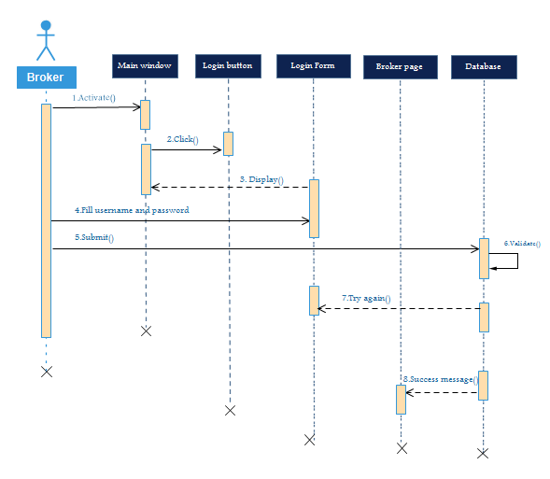
Fig.2.7 Sequence diagram for Broker login

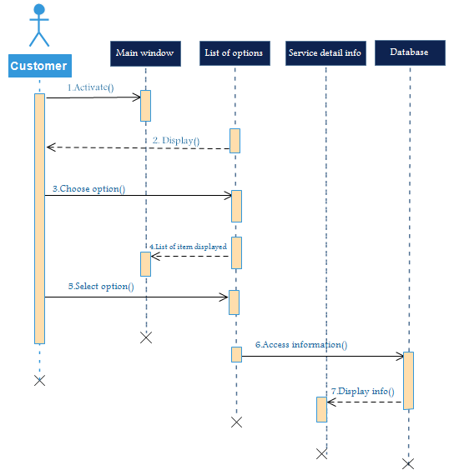
Fig.2.8 Sequence diagram for view service

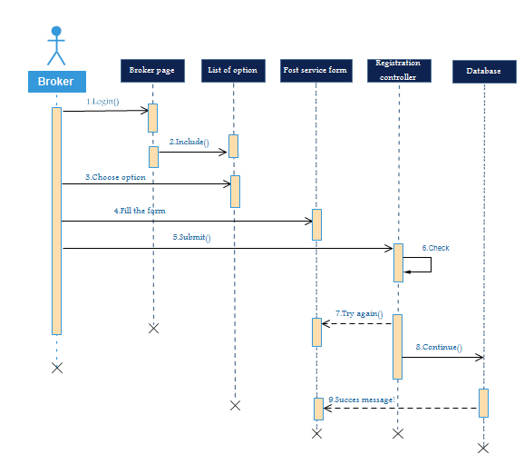
Fig.2.9 Sequence diagram for post service

2.3.6. State chart diagram
State chart diagram is used to describe the states of different objects in its life cycle. States can be identified as the condition of objects when a particular event occurs.
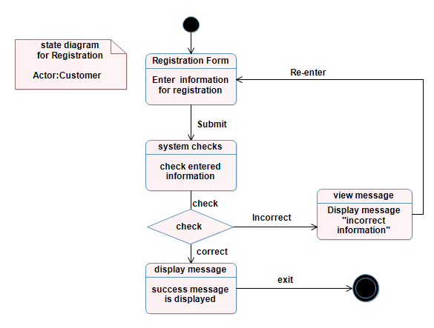
Fig.2.10 State chart diagram for Registration

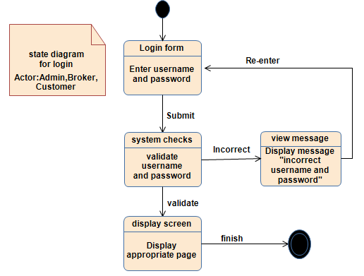
Fig.2.11 State chart diagram for Login
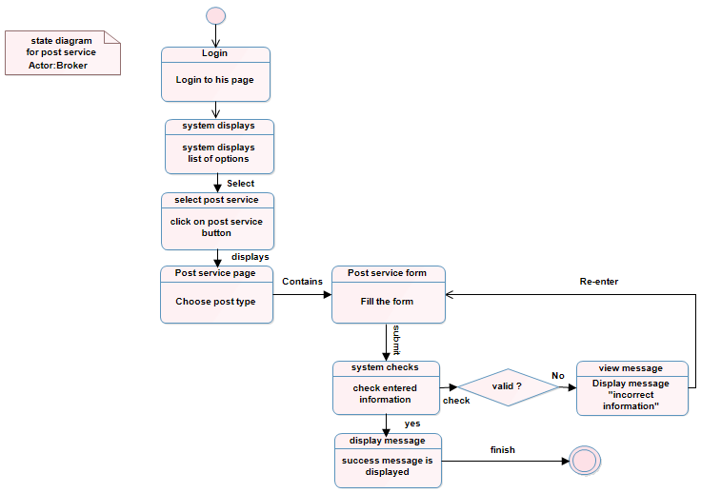
Fig.2.12 State chart diagram for Post service

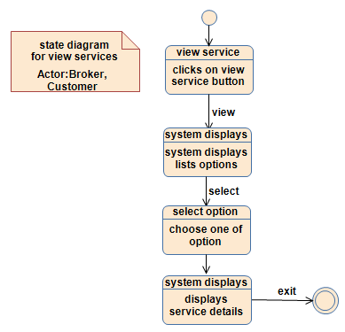
Fig.2.13 State chart diagram for View service
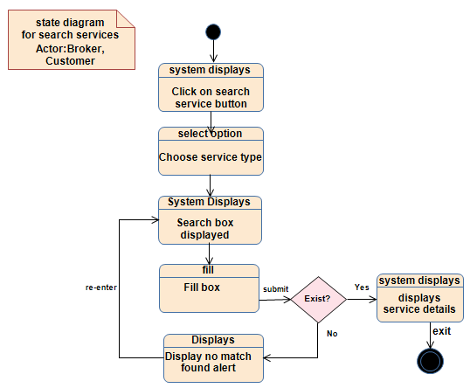
Fig.2.14 State chart diagram for Search service
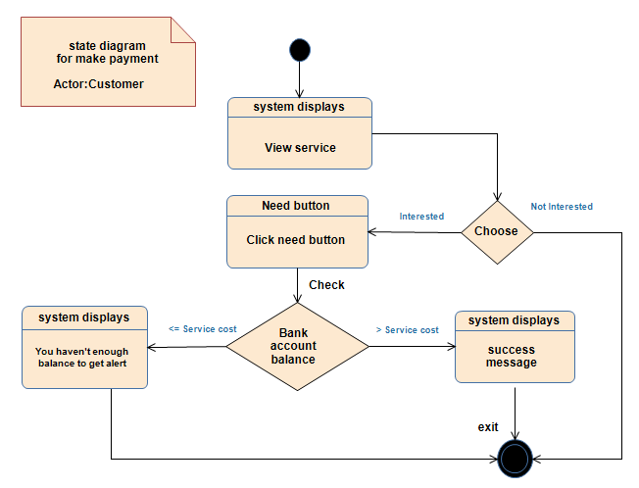
Fig.2.15 State chart diagram for Make payment

2.3.7. Activity Diagram
Is one of the components of UML. It highlights the activities performed in the system. Each activity is represented by a narrow and more oval shape. They are used to document the logic of a single operation/method, a single use case, or flow of logic of business operation. They are the object oriented equivalent of flow charts and data flow diagrams (DFD) from structured development. This part of the project documentation consists of an activity diagram that shows the flow of action in main use cases.
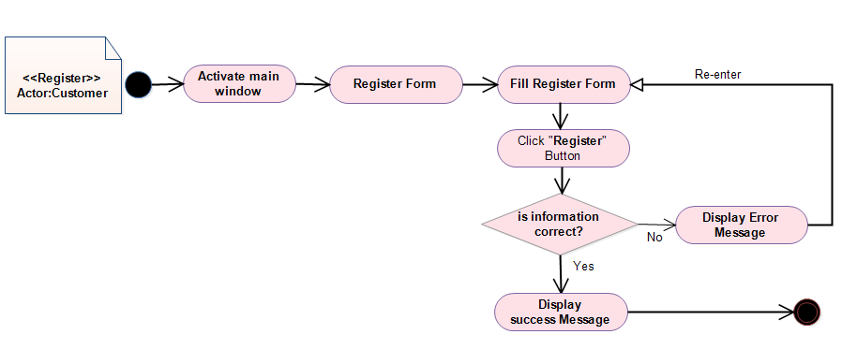
Fig.2.16 Activity diagram for Customer registration.
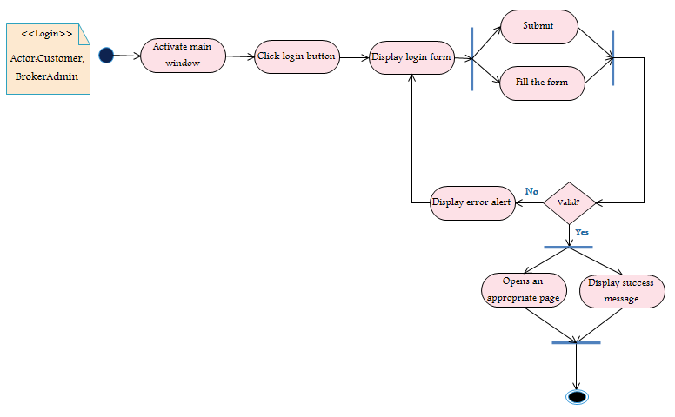
Fig.2.17 Activity diagram for Login

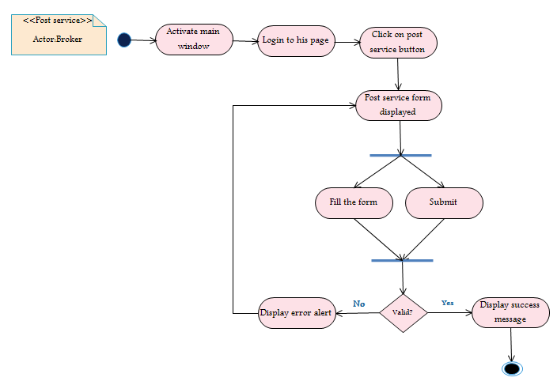
Fig.2.18 Activity diagram for post service
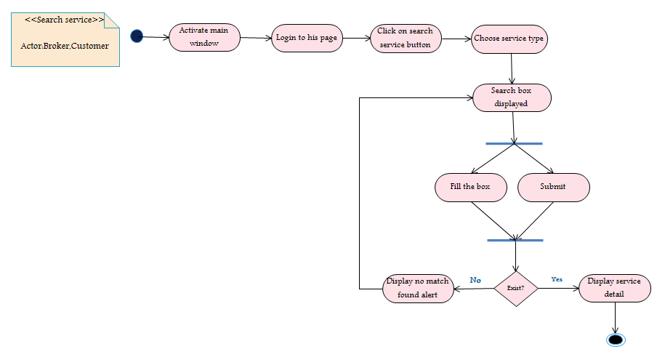
Fig.2.19 Activity diagram for search service

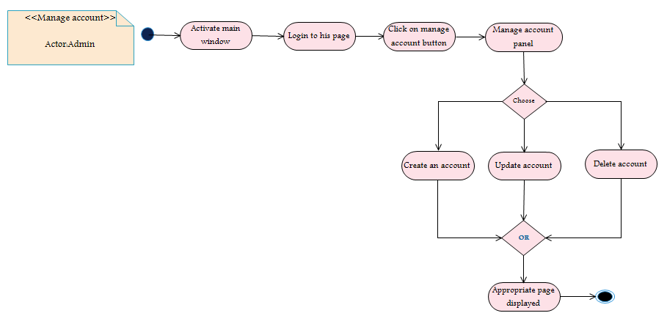
Fig.2.20 Activity diagram for Manage account.

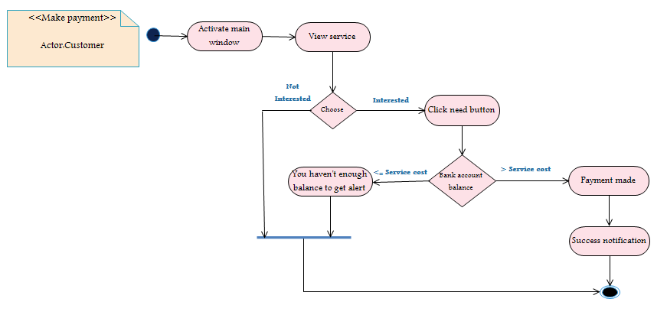

Fig.2.21 Activity diagram for Make payment

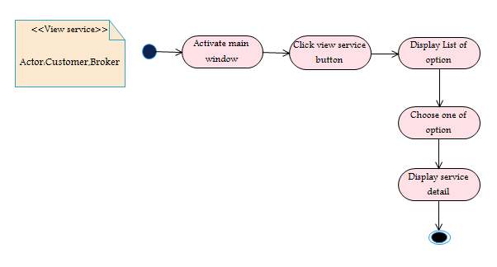
Fig.2.22 Activity diagram for view service

2.3.8. Collaboration diagram
Collaborative diagram emphasizes the context and the overall organization of the objects that interact. It shows the message the object sends in addition to the association among objects.A label near the arrow shows what the message is. The message typically tells the receiving object to execute one of its operations.
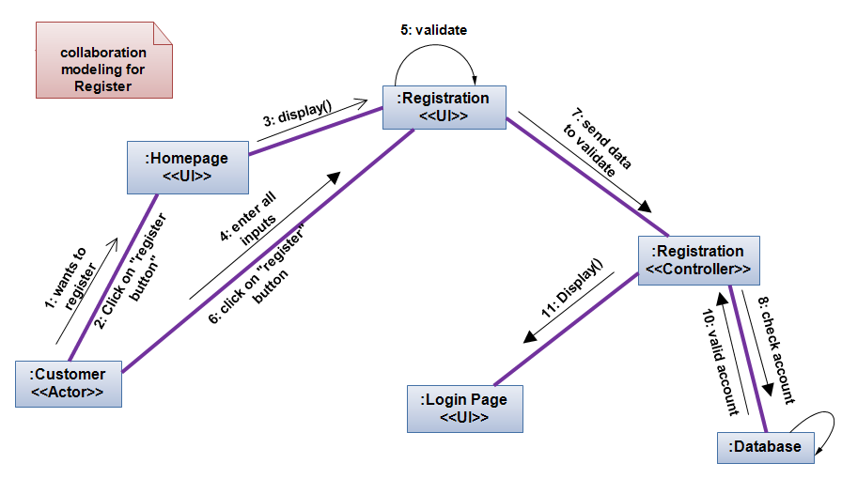
Fig.2.23 Collaboration diagram for Registration
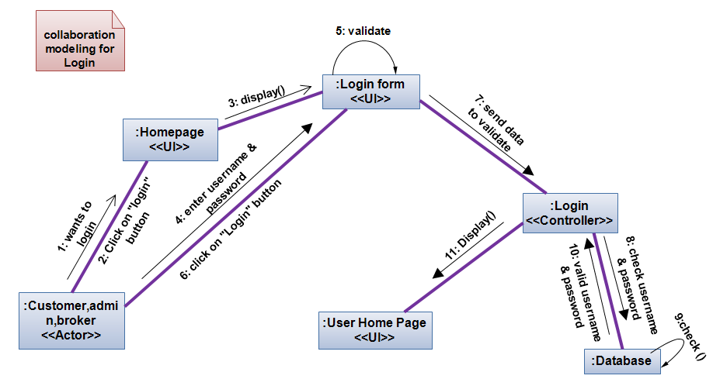
Fig.2.24 Collaboration diagram for Login
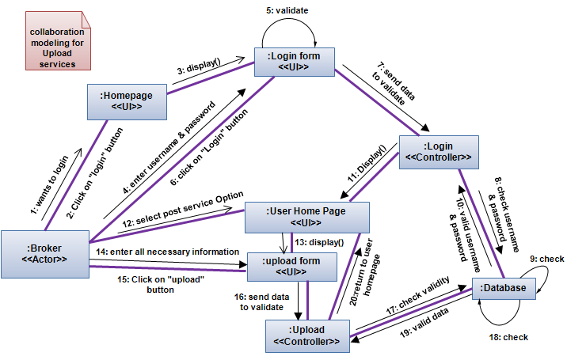
Fig.2.25 Collaboration diagram for Upload service
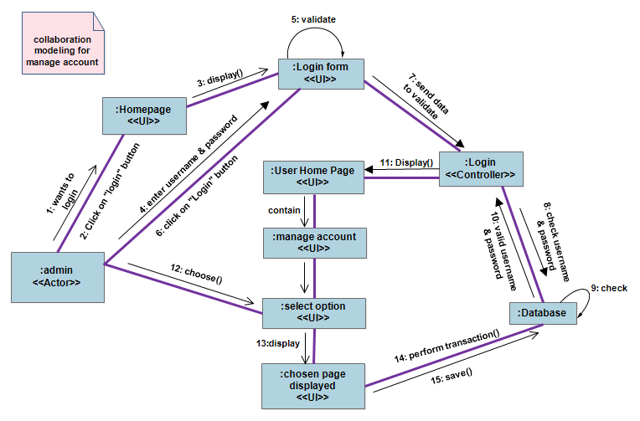
Fig.2.26 Collaboration diagram for Manage account
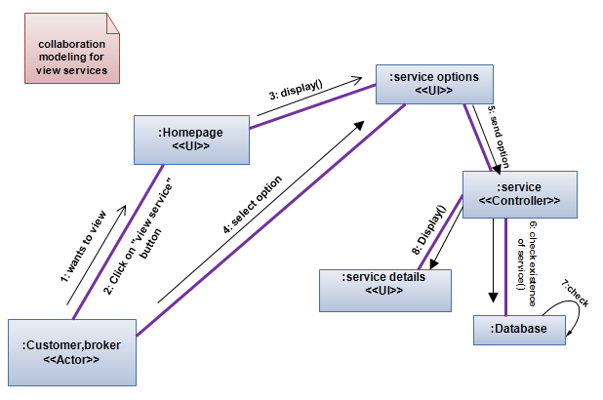
Fig.2.27 Collaboration diagram for View service

2.3.9. Class diagram
UML class diagram shows the classes of the system, their interrelationships (including inheritance, aggregation, and association), and the operation and attributes of the class. It shows the static structure of the model, in particular, the things that exist (such as classes and types), their internal structure, and their relationships to other things. This project used class diagram to design the structures that will be included in the system and the things that will be exist in the system.
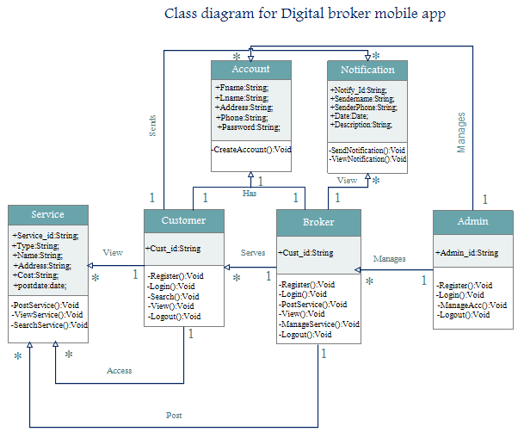
Fig.2.28 Class diagram for the system

User Interface prototyping
Mobile based Digital broker system has easy and user friendly user interfaces. This application contains server side containing the database of the services, customer and broker(web application user interface); and a client side containing GUI (graphical user interface).
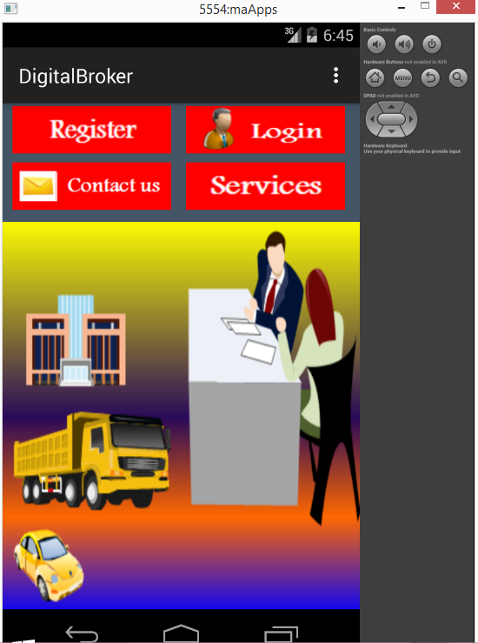
Fig 2.29 User interface prototype for Main menu.

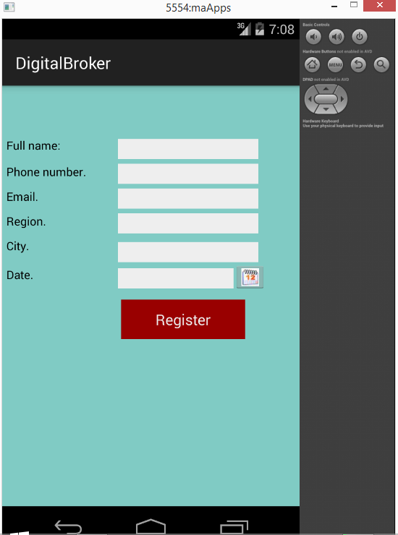
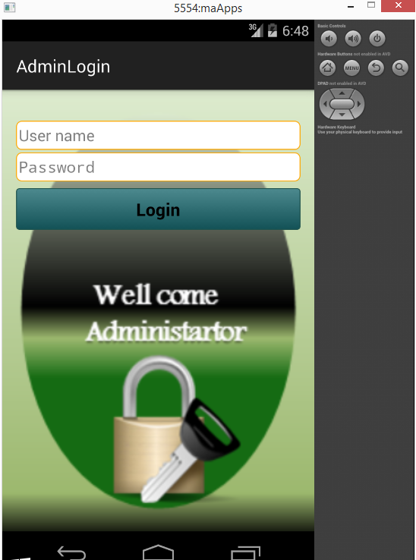 Fig 2.30 User interface prototype for Admin login page. Fig 2.31 prototype for Register

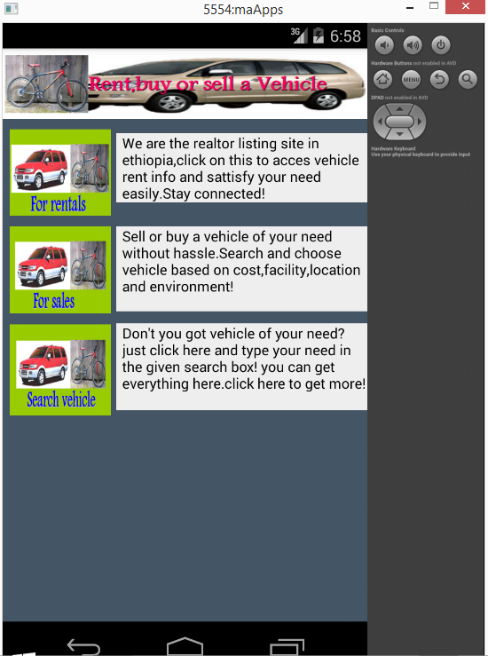
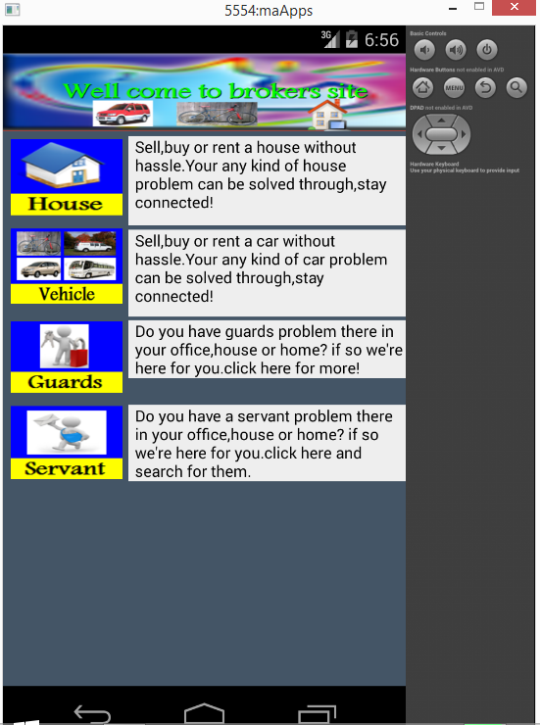
Fig 2.30 User interface prototype for Service page.
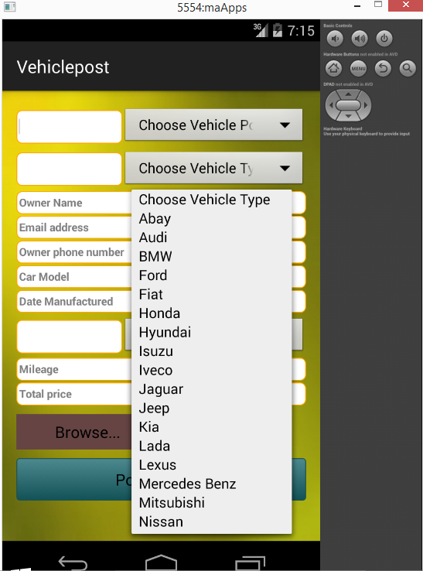
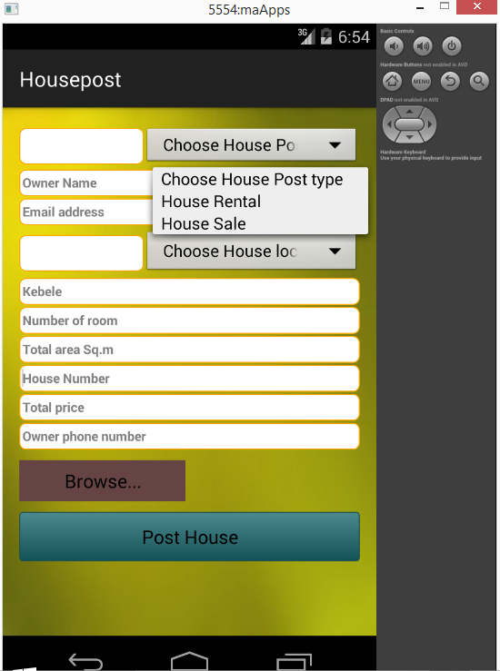
Fig 2.30 User interface prototype for Post service form.

